DATA ANALYTICS ON WEATHER MONITORING STATION
A Project Report
Submitted in the partial fulfillment of the requirements for the award of the degree of

Bachelor of Technology

in
Department of Computer Science and Engineering
By
N Jaya Simha Reddy (150040588)
K. Jaya Srikanth (150030389)
K. V. V. Abhinov Kumar (150030390)
M. H. K. Surya Prasad (150030584)
Under the Supervision of

Mr. K. Sripath Roy

Assistant Professor

KONERU LAKSHMAIAH EDUCATION FOUNDATION
Green Fields, Vaddeswaram- 522502, Guntur(Dist), Andhra Pradesh, India.
November – 2018
KONERU LAKSHMAIAH EDUCATION FOUNDATION
DEPARTMENT OF COMPUTER SCIENCE AND ENGINEERING

Declaration

The Project Report entitled “Data Analytics on Weather Monitoring Station“ is a record of bonafide work of K.Jaya Srikanth (150030389), K.V.V.Abhinov Kumar (150030390) and M. H. K. Surya Prasad(150030584) submitted in partial fulfillment for the award of Bachelor of Technology in Computer Science and Engineering during the academic year 2018-19.

We also declare that this report is of our own effort and it has not been submitted to any other university for the award of any degree.

K. Jaya Srikanth (150030389)
K. V. V. Abhinov Kumar (150030390)
M. H. K. Surya Prasad (150030584)
KONERU LAKSHMAIAH EDUCATION FOUNDATION
DEPARTMENT OF COMPUTER SCIENCE AND ENGINEERING

Certificate

This is to certify that the Project Report entitled “Data Analytics on Weather Monitoring Station” is being submitted by K.Jaya Srikanth (150030389), K.V.V.Abhinov Kumar (150030390) and M. H. K. Surya Prasad(150030584) in partial fulfillment for the award of Bachelor of Technology in Computer Science and Engineering during the academic year 2018-19.

Signature of the Supervisor Signature of the HOD
Mr. K. Sripath Roy Dr. Hari Kiran Vege
Asst Professor Head of the Department

Signature of the EXTERNAL EXAMINER

ACKNOWLEDGEMENT
This research project would not have been possible without the support of many people. We are very grateful to them in making our project a huge successful one. We the entire group members would like to acknowledge the advice, encouragement and guidance of those people.
Firstly we would like to place on record the deep sense of gratitude to the honorable Prof. L. S. S. Reddy, Vice Chancellor, Koneru Lakshmaiah Educational Foundation for providing the necessary facilities to carry on the project with ease of access.
We would like to thank the Head of the Department, Dr.Hari Kiran Vege, Professor in Computer Science and Engineering department for his valuable suggestions and his guidance for the timely completion of the project.
It is our immense pleasure to acknowledge KL NSS for the co-operation and support for sharing the valuable data which is the key requirement of the project.
And It is always been our pleasure to be a part of KL GLUG for its great flexibility of the stream/Technology on what we want to work on and also its friendly environment .
Furthermore, we are also very much thankful to our guide K. Sripath Roy, Asst Professor in Electronics and Communication Engineering for his valuable advice and motivation throughout and the completion of this project. His technical knowledge was an invaluable asset, but may be more importantly, he has helped to keep us focused and pointed in the right direction.

K.Jaya Srikanth (150030389)
K.V.V.AbhinovKumar (150030390)
M. H. K. Surya Prasad (150030584)
ABSTRACT
Weather Monitoring Stations have been widely used to collect the temperature, humidity data from sources in different locations and monitor the data at a weather station. In this project, we have implemented a weather station that monitors weather data from different villages nearby, collects the data and visualizes it on a single dashboard. This helps us to monitor the data with ease. To make use of the collected data, we are applying various Machine Learning models using python to predict the upcoming data by using the current and previous data. By engaged on this, we have a tendency to decide which algorithmic program suits higher for a given data by applying every algorithm on the data and verifying the accuracy by varying different parameters supported the model. Furthermore, we have done Digital Penetration Survey on village survey data collected by NSS cell to gather various patterns out of the data. Perfoming data analytics on this data helps us analyze the impact of technology in rural areas and help the government while introducing new schemes and also to monitor the progress and development in rural areas.
LIST OF FIGURES PAGENO

2.1 IOT Block Diagram 11
2.2 Example of MQTT broker 13
2.3 NodeMCU 16
2.4 MCP9808 Temperature sensor 20
2.5 HDC1080 Humidity sensor 21
3.1 Interfacing NodeMCU with DHT11 22
3.2 MQTT block diagram 24
3.3 Thingsboard login 27
3.4 Gathering live data in Thingsboard 27
3.5 Rule Chains in Thingsboard 28
3.6 Temperature emulator 29
4.1 Sample Dataset 29
4.2 Data Information 30
4.3 Scatter plot on NSS data 31
4.4 Box plot on Data 31
4.5 Understanding Support Vectors 32
4.6 Demonstration of Logistic Regression Model 33
4.7 Decision Tree 34
4.8 KNN model 35
4.9 Analysis of NSS data 36
5.1 Sample Dataset 37
5.2 Vizualization of each attribute from test data 41
5.3 Histogram Plot of the data 45
5.4 Training and testing datasets 46
5.5 Ordinary Least Squares Model 47
5.6 Visualization of relationships 51
5.7 Mean Absolute Error 52
CONTENTS
TITLE PAGE NO
ABSTRACT
LIST OF FIGURES
CHAPTER-1 :INTRODUCTION 9
1.1 Whether Monitoring Station 9
1.2 What is Open Source? 10
CHAPTER-2 LITERATURE SURVEY 11
2.1 Internet of Things 11
2.2 IOT protocols 12
2.3 NodeMCU 16
2.4 Thingsboard 17
2.5 Machine Learning 18
2.6 Sensors used in Weather Monitoring 20
CHAPTER-3 WEATHER MONITORING STATION USING IOT 22
3.1 Configure the Hardware 22
3.2 Programming NodeMCU 23
3.3 MQTT protocol 24
3.4 Data Collection 25
3.5 Data Visualization in Thingsboard 26
CHAPTER-4 DATA ANALYTICS 30
4.1 Dataset Collection 30
4.2 Tools and packages used 30
4.3 Featuring Scaling of data 31
4.4 Analysing models 32
4.5 Boosting Algorithms 36
4.6 Data Visualization 37
CHAPTER-5 PREDICTION OF WEATHER DATA 38
5.1 Data retrieval and cleaning 38
5.2 Understanding the Data 39
5.3 Dividing dataset into training and testing data 43
5.4 Applying Regression Models 46
CHAPTER-6 CONCLUSION 54
CHAPTER-7 FUTURE SCOPE 55 CHAPTER-8 REFERENCES 56
CHAPTER–1 INTRODUCTION
1.1 WEATHER MONITORING STATION
In human life weather monitoring plays an important role, as the data collection related to dynamically changing weather conditions are important. It is very important to monitor weather in packaging industry during certain hazards. The monitoring of weather parameters in an industry and also in a room can be done by using the weather monitoring system. The design of such a system is discussed in this paper. The weather monitoring system contains DHT sensor by which temperature and humidity will be monitored. The data from the sensors are collected by the micro controller and also micro controller sends the sensors data in to the Arduino Software (IDE) by using the Serial Communication. The system is used for maintaining the bv temperature and humidity in a room. It is going to sense temperature and humidity of targeted area not city or village. Climate Monitoring Stations have been broadly used to gather the temperature, moistness information from sources in various areas and screen the information at a climate station. In this task, we have executed a climate station that screens climate information from various towns adjacent, gathers the information and imagines it on a solitary dashboard. This encourages us to screen the information easily. To make utilization of the gathered information, we are applying different Machine Learning models utilizing python to foresee the up and coming information by utilizing the current and past information. Performing information examination on this information encourages us investigate the effect of innovation in provincial zones and help the administration while acquainting new plans and furthermore with screen the advancement and improvement in country regions. One of the IoT applications is real-time weather monitoring. We provide solution to the observatory to achieve real-time monitoring of weather at different locations in the territories covered by mobile network. Weather information like temperature, wind direction and speed, humidity, flooding can be gathered via various measuring equipment in street weather station. All the data can be centralized, organized and sent to the observatory.

1.2. WHAT IS OPEN SOURCE?
All in all, open source alludes to any program whose source code is made accessible for utilize or change as clients or different designers see fit. Open source programming is typically created as an open coordinated effort and made uninhibitedly accessible. Open Source is a confirmation stamp possessed by the Open Source Initiative (OSI). Designers of programming that is proposed to be uninhibitedly shared and conceivably enhanced and redistributed by others can utilize the Open Source trademark if their appropriation terms fit in with the OSI's Open Source Definition. To condense, the Definition model of dispersion terms require that:
1. The product being conveyed must be redistributed to any other individual with no limitation.
2. The source code must be made accessible (with the goal that the getting party will have the capacity to enhance or adjust it).
3. The permit can require enhanced adaptations of the product to convey an alternate name or from the first programming.
Late improvements in open source equipment and programming stages (Android, Arduino, Linux, OpenCV and so on.) have empowered fast advancement of already costly and modern framework inside a bring down spending plan and compliment expectations to absorb information for engineers. Utilizing these stage, we planned and created a Java-based 3D mechanical reproduction framework, with chart database, which is incorporated in on the web and disconnected modes with an Android-Arduino based waste picking remote control vehicle. The blend of the open source equipment and programming framework made an adaptable and expandable stage for further advancements later on, both in the product and equipment territories, specifically in mix with chart database for man-made brainpower, and more modern equipment, for example, legged or humanoid robots. This paper traces the utilizations of open source equipment and programming modules, as recorded beneath, with the end goal to make a minimal effort, coordinated stage (including both equipment and programming) for research and additionally instructing and learning in mechanical technology and man-made brainpower.
CHAPTER-2 LITERATURE SURVEY
2.1 INTERNET OF THINGS
The Internet of Things (IoT) is a computing concept that describes the idea of everyday physical objects being connected to the internet and being able to identify themselves to other devices. The term is closely identified with RFID as the method of communication, although it also may include other sensor technologies, wireless technologies or QR codes. The IoT is significant because an object that can represent itself digitally becomes something greater than the object by itself. No longer does the object relate just to its user, but it is now connected to surrounding objects and database data. When many objects act in unison, they are known as having "ambient intelligence."
The term IoT is principally utilized for gadgets that wouldn't ordinarily be by and large anticipated that would have a web association, and that can speak with the system freely of human activity. Thus, a PC isn't by and large thought about an IoT gadget nor is a cell phone. Despite the fact that the last is packed with sensors. A smartwatch or a wellness band or other wearable gadget may be considered an IoT gadget. Huge and getting greater, there are as of now more associated things than individuals on the planet.
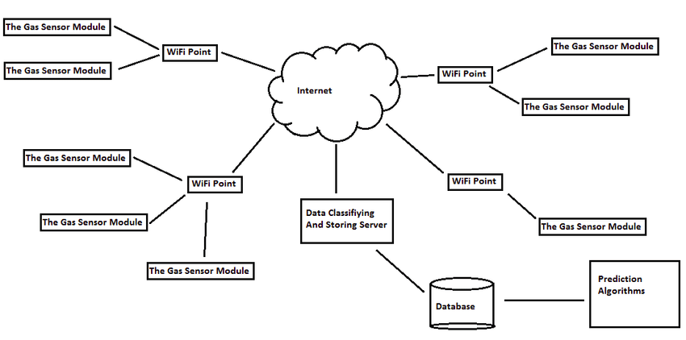
Figure 2.1 IOT Block Diagram
Out of that 8.4 billion gadgets, the greater part will be buyer items like shrewd TVs and keen speakers. The most-utilized endeavor IoT gadgets will be brilliant electric meters and business surveillance cameras, as per Gartner. Every so often known as the Industrial IoT, the advantages of the IoT for business rely upon the specific execution, however the key is that undertakings ought to approach more information about their very own items and their own inner frameworks, and a more prominent capacity to roll out improvements accordingly.

2.2 IOT PROTOCOLS
The IoT needs standard protocols. Two of the most promising for small devices are MQTT and CoAP.
Both MQTT and CoAP:
- Are open standards
- Are better suited to constrained environments than HTTP
- Provide mechanisms for asynchronous communication
- Run on IP
- Have a range of implementations
MQTT gives flexibility in communication patterns and acts purely as a pipe for binary data.
CoAP is designed for interoperability with the web.

MQTT:
MQTT is a publish/subscribe messaging protocol designed for lightweight M2M communications. It was originally developed by IBM and is now an open standard. MQTT has a client/server model, where every sensor is a client and connects to a server, known as a broker, over TCP. MQTT is message oriented. Every message is a discrete chunk of data, opaque to the broker. Every message is published to an address, known as a topic. Clients may subscribe to multiple topics. Every client subscribed to a topic receives every message published to the topic. For example, imagine a simple network with three clients and a central broker. All three clients open TCP connections with the broker. Clients B and C subscribe to the topic temperature. In MQTT, topics are hierarchical, like a filing system (eg. kitchen/oven/temperature). Wildcards are allowed when registering a subscription (but not when publishing) allowing whole hierarchies to be observed by clients.

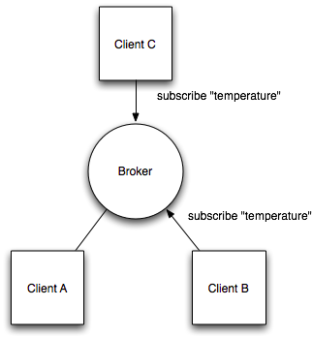

Figure 2.2 Example of MQTT broker

- In MQTT, points are various leveled, similar to a recording framework (eg. kitchen/stove/temperature). Special cases are permitted while enlisting a membership (however not when distributing) enabling entire chains of command to be seen by customers.
- MQTT customers can enlist a custom "last will and confirmation" message to be sent by the dealer in the event that they detach. These messages can be utilized to motion to endorsers when a gadget separates.
- MQTT has bolster for tenacious messages put away on the agent. When distributing messages, customers may ask for that the specialist holds on the message. Just the latest diligent message is put away. At the point when a customer buys in to a theme, any continued message will be sent to the customer.
- Not at all like a message line, MQTT dealers don't permit persevered messages to back up inside the server.
- MQTT agents may require username and secret word verification from customers to associate. To guarantee protection, the TCP association might be encoded with SSL/TLS.
- Despite the fact that MQTT is intended to be lightweight, it has two downsides for extremely obliged gadgets.
- Each MQTT customer must help TCP and will commonly hold an association open to the agent consistently. For a few conditions where bundle misfortune is high or figuring assets are rare, this is an issue.
- MQTT point names are frequently long strings which make them unrealistic for 802.15.4.
- Both of these deficiencies are tended to by the MQTT-SN convention, which characterizes a UDP mapping of MQTT and includes intermediary bolster for ordering point names.

COAP
Like HTTP, CoAP is a document transfer protocol. Unlike HTTP, CoAP is designed for the needs of constrained devices. CoAP packets are much smaller than HTTP TCP flows. Bitfields and mappings from strings to integers are used extensively to save space. Packets are simple to generate and can be parsed in place without consuming extra RAM in constrained devices. CoAP runs over UDP, not TCP. Clients and servers communicate through connectionless datagrams. Retries and reordering are implemented in the application stack. Removing the need for TCP may allow full IP networking in small microcontrollers. CoAP allows UDP broadcast and multicast to be used for addressing. CoAP follows a client/server model. Clients make requests to servers, servers send back responses. Clients may GET, PUT, POST and DELETE resources. CoAP is designed to interoperate with HTTP and the RESTful web at large through simple proxies. Because CoAP is datagram based, it may be used on top of SMS and other packet based communications protocols.
Like HTTP, CoAP underpins content transaction. Customers utilize Accept alternatives to express a favored portrayal of an asset and servers answer with a Content-Type choice to tell customers what they're getting. Likewise with HTTP, this enables customer and server to develop freely, including new portrayals without influencing one another. Since CoAP is based over UDP not TCP, SSL/TLS are not accessible to give security. DTLS, Datagram Transport Layer Security gives indistinguishable confirmations from TLS yet for exchanges of information over UDP. Regularly, DTLS able CoAP gadgets will bolster RSA and AES or ECC and AES. CoAP expands the HTTP ask for model with the capacity to watch an asset. At the point when the watch hail is determined to a CoAP GET ask for, the server may keep on answering after the underlying record has been exchanged. This enables servers to stream state changes to customers as they happen. Either end may drop the perception. In CoAP, a sensor hub is regularly a server, not a customer (however it might be both). The sensor (or actuator) gives assets which can be gotten to by customers to peruse or adjust the condition of the sensor. As CoAP sensors are servers, they should have the capacity to get inbound parcels. To work legitimately behind NAT, a gadget may initially send a demand out to the server, as is done in LWM2M, enabling the switch to relate the two. In spite of the fact that CoAP does not require IPv6, it is simplest utilized in IP conditions where gadgets are straightforwardly routable.

COMPARISION
MQTT and CoAP are both helpful as IoT conventions, however have basic contrasts. MQTT is a many-to-numerous correspondence convention for passing messages between various customers through a focal representative. It decouples maker and purchaser by giving customers a chance to distribute and having the representative choose where to course and duplicate messages. While MQTT has some help for steadiness, it does best as an interchanges transport for live information. CoAP is, basically, a coordinated convention for exchanging state data among customer and server. While it has bolster for watching assets, CoAP is most appropriate to a state exchange display, not absolutely occasion based. MQTT customers make an enduring active TCP association with a merchant. This normally shows no issue for gadgets behind NAT. CoAP customers and servers both send and get UDP bundles. In NAT situations, burrowing or port sending can be utilized to
permit CoAP, or gadgets may initially start an association with the head-end as in LWM2M. MQTT gives no help to naming messages with sorts or other metadata to enable customers to comprehend it. MQTT messages can be utilized for any reason, however all customers must realize the message organizes in advance to permit correspondence. CoAP, then again, gives inbuilt help to content arrangement and revelation enabling gadgets to test each other to discover methods for trading information.

2.3 NODEMCU
NodeMCU is an open source LUA based firmware produced for ESP8266 wifi chip. By investigating usefulness with ESP8266 chip, NodeMCU firmware accompanies ESP8266 Development board/unit i.e. NodeMCU Development board. Since NodeMCU is open source stage, their equipment configuration is open for alter/adjust/manufacture. NodeMCU Dev Kit/board comprise of ESP8266 wifi empowered chip. The ESP8266 is a minimal effort Wi-Fi chip created by Espressif Systems with TCP/IP convention. For more data about ESP8266, you can allude ESP8266 WiFi Module. NodeMCU Dev Kit has Arduino like Analog (i.e. A0) and Digital (D0-D8) sticks on its board. It underpins sequential correspondence conventions i.e. UART, SPI, I2C and so forth. Utilizing such sequential conventions we can interface it with sequential gadgets like I2C empowered LCD show, Magnetometer HMC5883, MPU-6050 Gyro meter + Accelerometer, RTC chips, GPS modules, contact screen shows, SD cards and so forth.
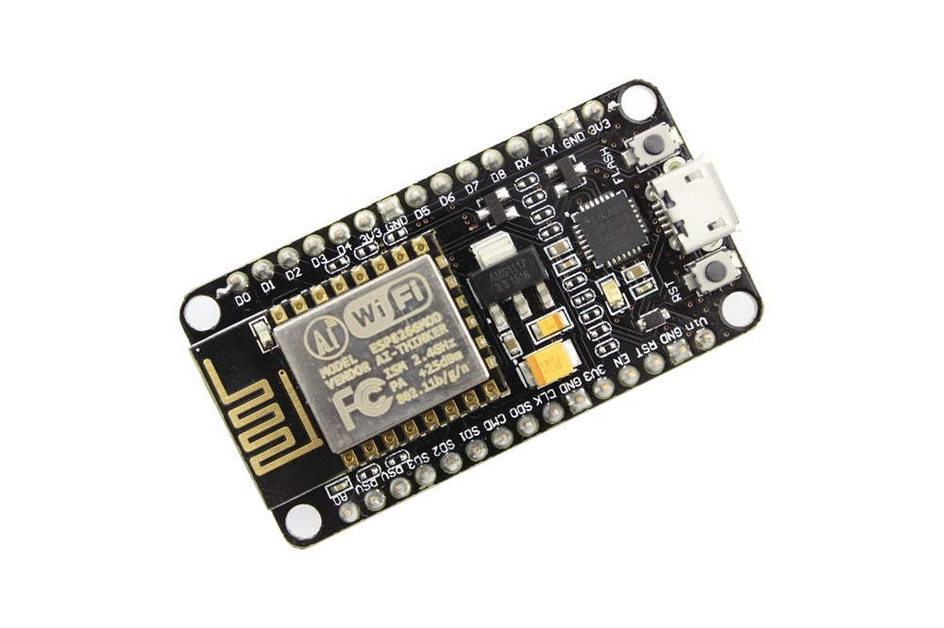

Figure 2.3 NodeMCU
NodeMCU Development board is included with wifi ability, simple stick, computerized pins and sequential correspondence conventions. We can likewise create applications on NodeMCU utilizing Arduino advancement condition. This makes simple for Arduino engineers than adapting new dialect and IDE for NodeMCU.

2.4 THINGSBOARD
ThingsBoard is an open-source IoT stage that empowers fast improvement, administration and scaling of IoT ventures. We will likely give the out-of-the-crate IoT cloud or on-premises arrangement that will empower server-side foundation for your IoT applications.
Features:
- With ThingsBoard, you can:
- Arrangement gadgets, resources and clients and characterize relations between them.
- Gather and picture information from gadgets and resources.
- Break down approaching telemetry and trigger alerts with complex occasion handling.
- Control your gadgets utilizing remote technique calls (RPC).
- Manufacture work processes dependent on gadget life-cycle occasion, REST API occasion, RPC ask for, and so on
- Structure dynamic and responsive dashboards and present gadget or resource telemetry and bits of knowedge to your clients
- Empower utilize case particular highlights utilizing adjustable guideline chains.
- Drive gadget information to different frameworks.

Thingsboard is designed to be:
- scalable: horizontally scalable platform, build using leading open-source technologies.
- fault-tolerant: no single-point-of-failure, every node in the cluster is identical.
- robust and efficient: single server node can handle tens or even hundreds thousands of devices depending on use-case. ThingsBoard cluster can handle millions of devices.
- customizable: adding new functionality is easy with customizable widgets and rule engine nodes.
- durable: never lose your data.
2.5 MACHINE LEARNING
Machine learning is a use of man-made reasoning (AI) that gives frameworks the capacity to naturally take in and enhance as a matter of fact without being unequivocally modified. Machine learning centers around the advancement of PC programs that can get to information and utilize it learn for themselves. The way toward learning starts with perceptions or information, for example, precedents, coordinate understanding, or guidance, with the end goal to search for examples in information and settle on better choices later on dependent on the models that we give. The essential point is to permit the PCs learn naturally without human intercession or help and alter activities in like manner. Machine learning algorithms are often categorized as supervised or unsupervised:
Supervised learning algorithms:
They can apply what has been realized in the past to new information utilizing marked precedents to anticipate future occasions. Beginning from the examination of a known preparing dataset, the learning calculation delivers a deduced capacity to make forecasts about the yield esteems. The framework can give focuses to any new contribution after adequate preparing. The learning calculation can likewise contrast its yield and the right, planned yield and discover mistakes with the end goal to alter the model in like manner. This is divided into two categories-
- Classification: When the output is classified under certain parameters like(an apple-red colour and banana-yellow colour).
- Regression: When the output variable is real value like(weight, lenght).

Unsupervised learning:
Unsupervised machine learning calculations are utilized when the data used to prepare is neither arranged nor marked. Unsupervised learning thinks about how frameworks can gather a capacity to depict a concealed structure from unlabeled information. The framework doesn't make sense of the correct yield, yet it investigates the information and can attract deductions from datasets to portray concealed structures from unlabeled information.
This is divided into two categories-
    - Clustering: When the data is to be grouped under similarities.
    - Association: Discribes a large set of data into some rules so that people who buys X are also like to buy Y...
Semi-supervised learning:
Semi-managed machine learning calculations fall some place in the middle of administered and unsupervised learning, since they utilize both marked and unlabeled information for preparing – normally a little measure of named information and a lot of unlabeled information. The frameworks that utilization this technique can significantly enhance learning exactness. As a rule, semi-managed learning is picked when the obtained marked information requires talented and pertinent assets with the end goal to prepare it/gain from it. Something else, acquiringunlabeled information by and large doesn't require extra assets.
Reinforcement Learning:
Support machine learning calculations is a learning technique that interfaces with its condition by delivering activities and finds mistakes or rewards. Experimentation look and deferred remunerate are the most pertinent attributes of fortification learning. This technique enables machines and programming specialists to naturally decide the perfect conduct inside a particular setting with the end goal to expand its execution. Straightforward reward criticism is required for the operator to realize which activity is ideal; this is known as the support flag.

2.6 SENSORS FOR WEATHER MONITORING
High Accuracy Temperature sensor:
MCP9808 is a extremely correct digital temperature sensor ±0.5°C I2C mini module. they're embodied with user- programmable registers that facilitate temperature sensing applications. The MCP9808 high-accuracy temperature sensor has become an industry standard in terms of form factor and intelligence, providing label, linearised sensor signals in digital, I2C format. To scan the temperature values, we've used Raspberry Pi with associate I2C adapter. This I2C adapter makes the association to the sensor module simple and a lot of reliable.
Features:
- 8-Channel Remote Diode Temperature Sensor Accuracy: ±0.75°C
- Fully Calibrated Temperature Sensing
- 12 or 14-Bit Resolution Digital Output I2C Interface
- Low-Power Consumption
- Excellent Long-Term Stability
- 0.3μA Shutdown Current
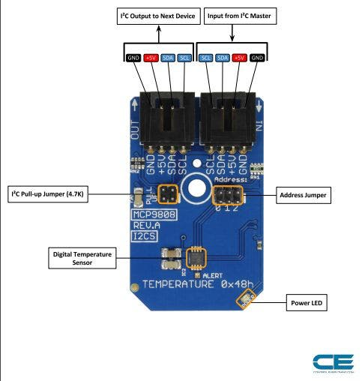
Figure 2.4 MCP9808 Temperature sensor

High Accuracy Humidity sensor:
HDC1080 High Accuracy Digital humidity sensor is a digital humidity sensor with integrated temperature detector. This sensor provides high measuring accuracy at very low power. The HDC1080 operates over a large provide vary, and could be a low value, low power various to competitive solutions in a very wide selection of common applications. The wetness and temperature sensors square measure plant mark. Typical applications embody HVAC, good thermostats monitors, printers, hand-held meters, medical devices, and wireless sensors
Features:
- Relative Humidity Accuracy ±2% (typical)
- Typical Drift: <0.5%/year
- Supply Current (Measuring): 180µA
- Temperature Accuracy ±0.2°C (typical)
- Excellent Stability at High Humidity
- Average Supply Current
- Supply Voltage 2.7V to 5.5V
- Temperature Range (Operating): -20ºC to +85ºC
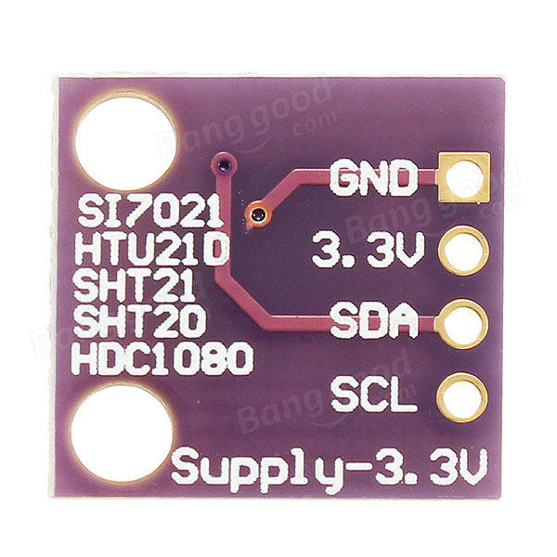
Figure 2.5 HDC1080 Humidity sensor

The above sensors are highly accurate and the cost is high. So, for this prototype model, we are using DHT11 Temperature and humidity sensor to measure the weather data.

CHAPTER-3 WEATHER MONITORING STATION USING IOT

3.1 CONFIGURE THE HARDWARE
Interfacing NodeMCU and DHT11:
The DHT11 identifies water vapor by estimating the electrical obstruction between two cathodes. The moistness detecting segment is a dampness holding substrate with anodes connected to the surface. At the point when water vapor is consumed by the substrate, particles are discharged by the substrate which expands the conductivity between the terminals. The adjustment in obstruction between the two terminals is corresponding to the relative moistness. Higher relative dampness diminishes the obstruction between the cathodes, while bring down relative moistness builds the opposition between the anodes.
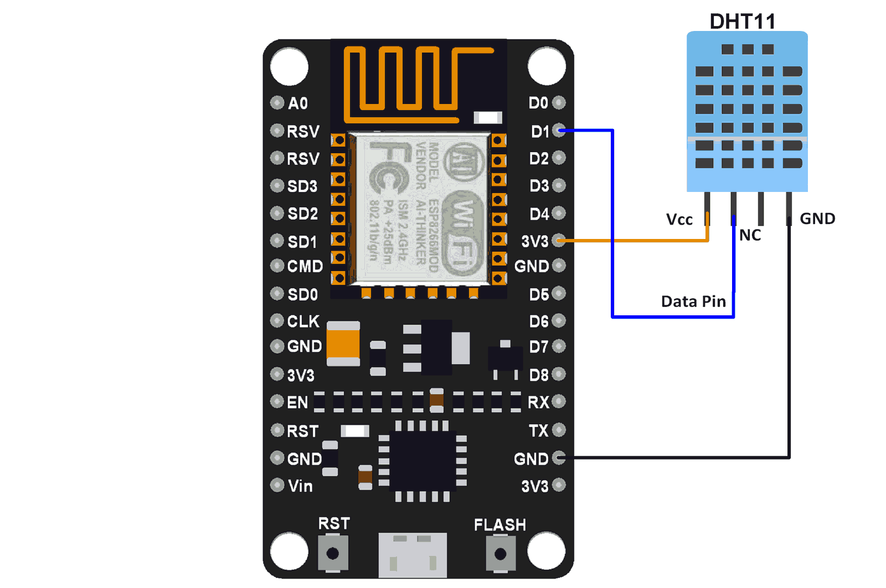
Figure 3.1 Interfacing NodeMCU with DHT11
Connect VCC and GND of DHT11 to 3v3 and GND and tthe data pin to one of the digital pins. We use DHT11 to get the temperature and humidity data and we interface it with NodeMCU. DHT11 sensor measures and gives stickiness and temperature esteems sequentially over a solitary wire. It can gauge relative dampness in rate (20 to 90% RH) and temperature in degree Celsius in the scope of 0 to 50°C. It has 4 pins; one of which is utilized for information correspondence in sequential frame. Beats of various TON and TOFF are decoded as rationale 1 or rationale 0 or begin heartbeat or end of casing. After setting up the hardware, each equipment is placed in different villages and is connected to internet. This is setup in an obstsacle less area to monitor the weather effectively.

3.2 PROGRAMMING NODEMCU
To dump the arduino code into NodeMCU, we need to install ESP8266 Boards for NodeMCU and libraries for DHT sensor and MQTT connection.
Open arduino ide
goto >file>preferences
Add this url to additional boards' manager
http://arduino.esp8266.com/stable/package_esp8266com_index.json
Restart arduino ide
Goto >tools>Board>Boards Manager
Install ESP8266 boards
Restart arduino ide
Goto >tools>Board>select nodemcu 1.0
And setup com port
Set programmer as “Arduino ISP”
Connect the nodemcu board
Open the NodeMCU code that read data from DHT11 and communicates with MQTT server.
Dump the code into the NodeMCU and make sure are the connections are intact.
In order to communicate with the MQTT server, we need to add IP and port of the MQTT server in the NodeMCU code.
To interface with Thingsboard, we need to additionally add ACCESS TOKEN along with Ip address and port.
In order to connect to internet, we provide the ssid and passkey of the wireless network in the vicinity of the device.

3.3 MQTT PROTOCOL
In thingsboard, the platform supports multiple protocols like HTTP, MQTT,CoAP etc. But, with
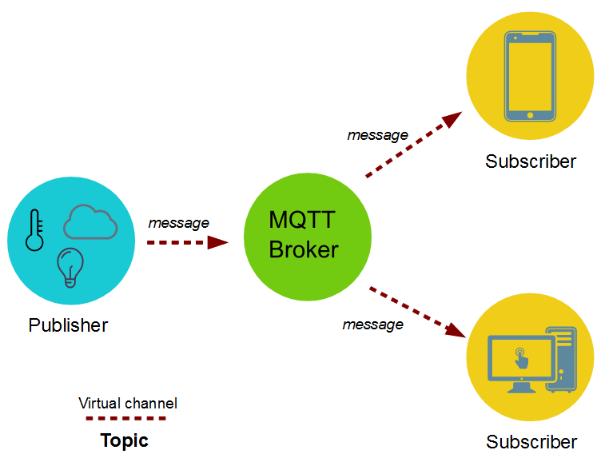
Figure 3.2 MQTT block diagram
respect to our project, we need to send the data continuously from device to thingsboard. So, we use MQTT over HTTP in order to use bandwidth efficiently and low power consumption.
At the core of utilizing MQTT as a correspondence road is the topic. It's a strikingly straightforward thought not one of a kind to MQTT; nonetheless, the MQTT convention use the intensity of this pleasantly. A theme certainly achieves a few assignments, above all guaranteeing that a message is conveyed to the right
audience members. MQTT regards a subject as a document way. When thinking about a topic as a straight forward correspondence channel, the way application can turn out to be amazing.
To install MQTT,
sudo apt-get install mosquitto mosquitto-clients
By default, Linux will start the Mosquitto service after install. Log in to your server a second time, so you have two terminals side-by-side. In the new terminal, use mosquitto_sub to subscribe to the test topic
$ mosquitto_sub -h localhost -t test
-h is used to specify the hostname of the MQTT server, and -t is the topic name. You'll see no output after hitting ENTER because mosquitto_sub is waiting for messages to arrive.
$mosquitto_pub -h localhost -t test -m "hello world"
Switch back to your other terminal and publish a message:
The options for mosquitto_pub are the same as mosquitto_sub, though this time we use the
additional -m option to specify our message.
In the NodeMCU code, we import Pubsubclient.zip library to support the MQTT operations. MQTT is a lightweight messaging protocol ideal for small devices. This library allows you to send and receive MQTT messages. It supports the latest MQTT 3.1.1 protocol and can be configured to use the older MQTT 3.1 if needed. It supports all Arduino Ethernet Client compatible hardware, including the Intel Galileo/Edison, ESP8266 and TI CC3000.

3.4 DATA COLLECTION
For data collection of the weather data, we use MySQL server with MQTT installed on the server end.
From this, we send the MQTT payload to mySQL database.
Create a Sample Table
create table text(varchar device, varchar attribute, varchar value, varchar timestamp );
Install python
goto python official website and download python latest
uzip it
open terminal
./configure
make
make install
Install pip
$ sudo apt-get install python-pip python-dev build-essential
$ sudo pip install --upgrade pip
sudo pip install MySQL-python (used to link mysql database)
pip install paho-mqtt( used to link mqtt data)
porject:
connect the dht11 sensor to digital pin of nodemcu
Uplode nodemcu code to nodemcu board(by doing all required changes)
wifi ssid and password
mqtt link
And in server side system start masquito server
Check this
$mosquitto_sub -t 'outopic' >log.txt
By adding database details to main.py
Run runthiscode.py

3.5 DATA VISUALIZATION IN THINGSBOARD
ThingsBoard enables you to design adjustable IoT dashboards. Each IoT Dashboard may contain numerous dashboard gadgets that envision information from different IoT gadgets. When IoT Dashboard is made, you may appoint it to one of the clients of you IoT venture.
IoT Dashboards are light-weight and you may have a large number of dashboards. For instance, you may consequently make a dashboard for each new client dependent on information from enlisted client IoT gadgets. Or on the other hand you may change dashboard through content when another gadget is doled out to a client. Every one of these activities might be done physically or computerized by means of REST API.
- Open http://demo.thingsboard.io and create an account and login.
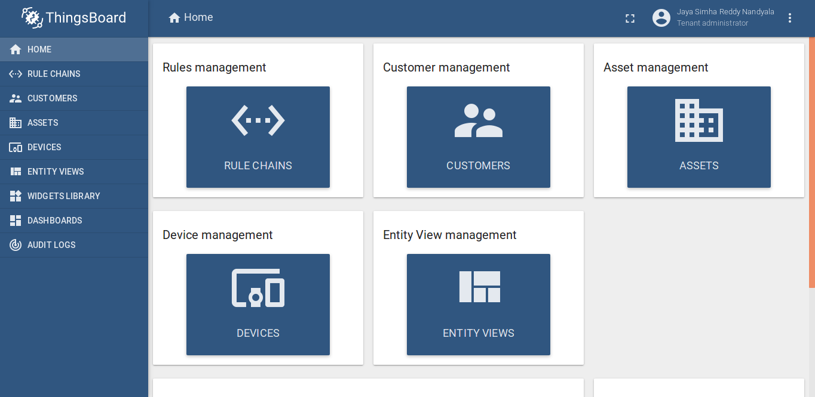
Figure 3.3 Thingsboard login
- Select devices and create a new device and choose as default type.
- Copy the Device access token and paste it in Node MCU code.
- Open Latest Telemetry to monitor the latest data received from the hardware device.
- Create a new Dashboard for Data Visualization
- Add new widget into the dashboard and add the nodeMCU device as a data source.
- Visualize the live data in dashboard.
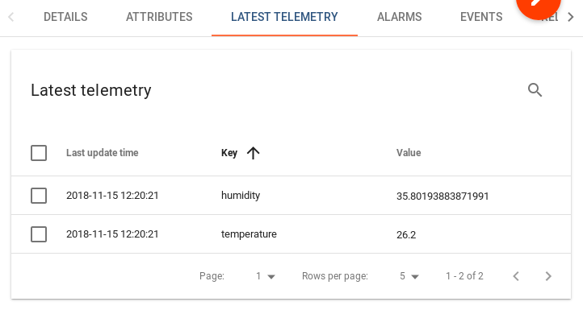
Figure 3.4 Gathering live data in Thingsboard
Further, depending on the application, we can write rule chains in order to perform operations like Alarms, sending email alerts etc. We can program the Rule Chains with Java Script.

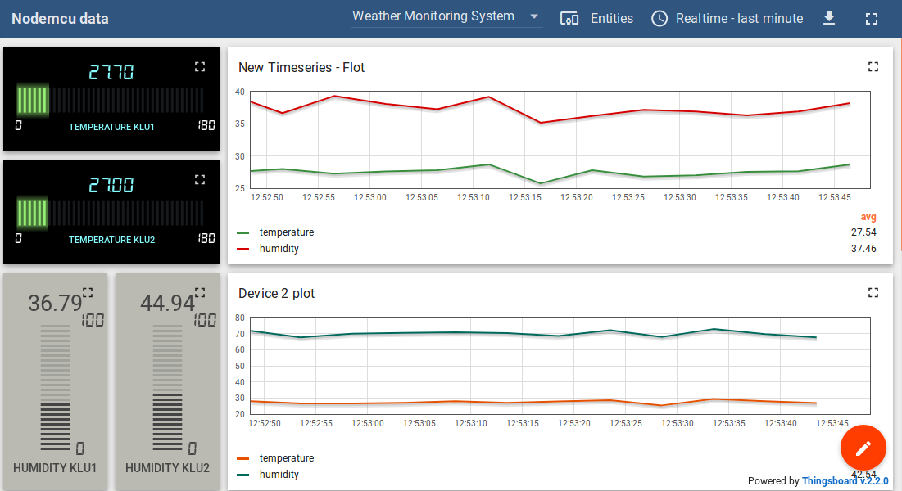
Figure 6.1 Visualization of live data from Nodemcu

3.6 RULE CHAINS IN THINGSBOARD
Rule Chains Administration UI page shows a table of arranged occupant rule chains. Each rule chain has a different card. You can do following tasks:
- Import Or Create new Rule Chain
- Fare Rule Chain to JSON
- Stamp Rule Chain as Root Rule Chain
- Erase the Rule Chain

Rule chains are used to define manual logics in our IOT system. We can create Alarms, or even automail generating functions when subjected to reaching a threshold value.
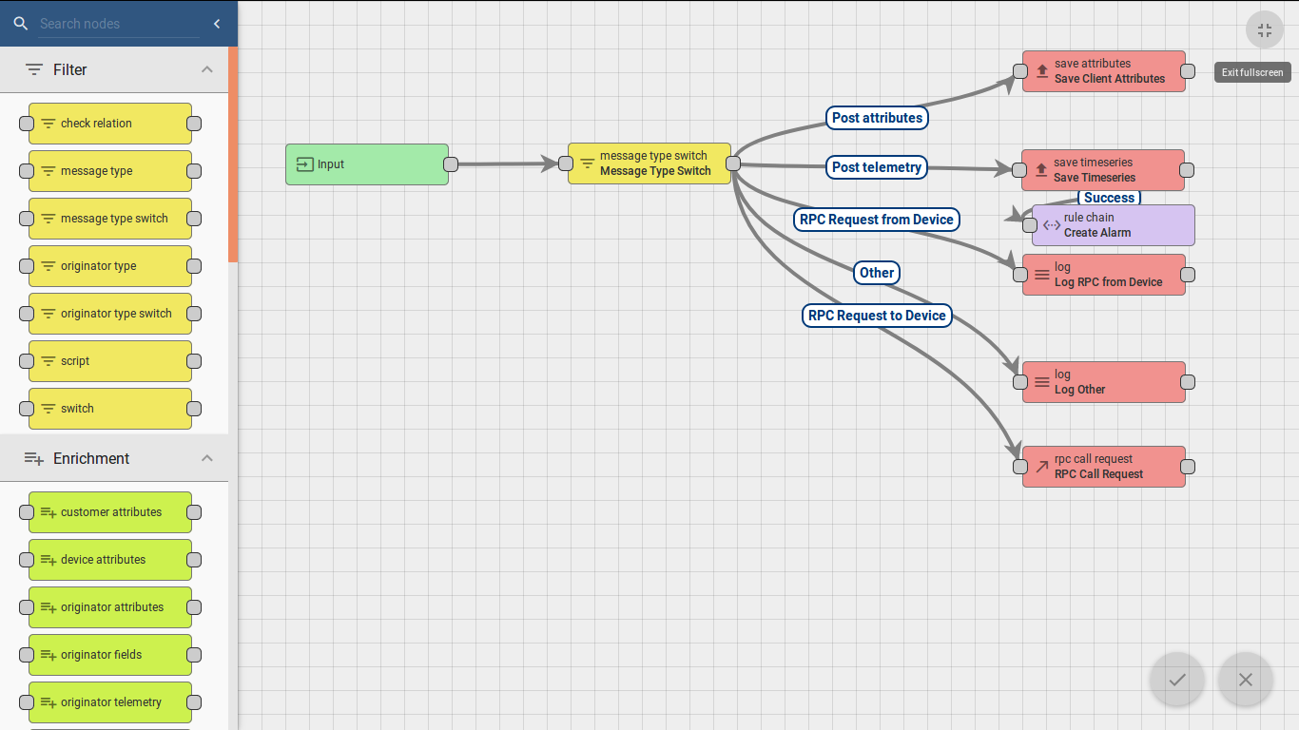
Figure 3.5 Rule Chains in Thingsboard

To program the Rule Chains, we use Java Script.
We cannot always fetch for harware while designing the system. So, for rapid prototyping, we have enabled a temperature emulator so that we can perform rapid prototyping during the vizualization and further processes.
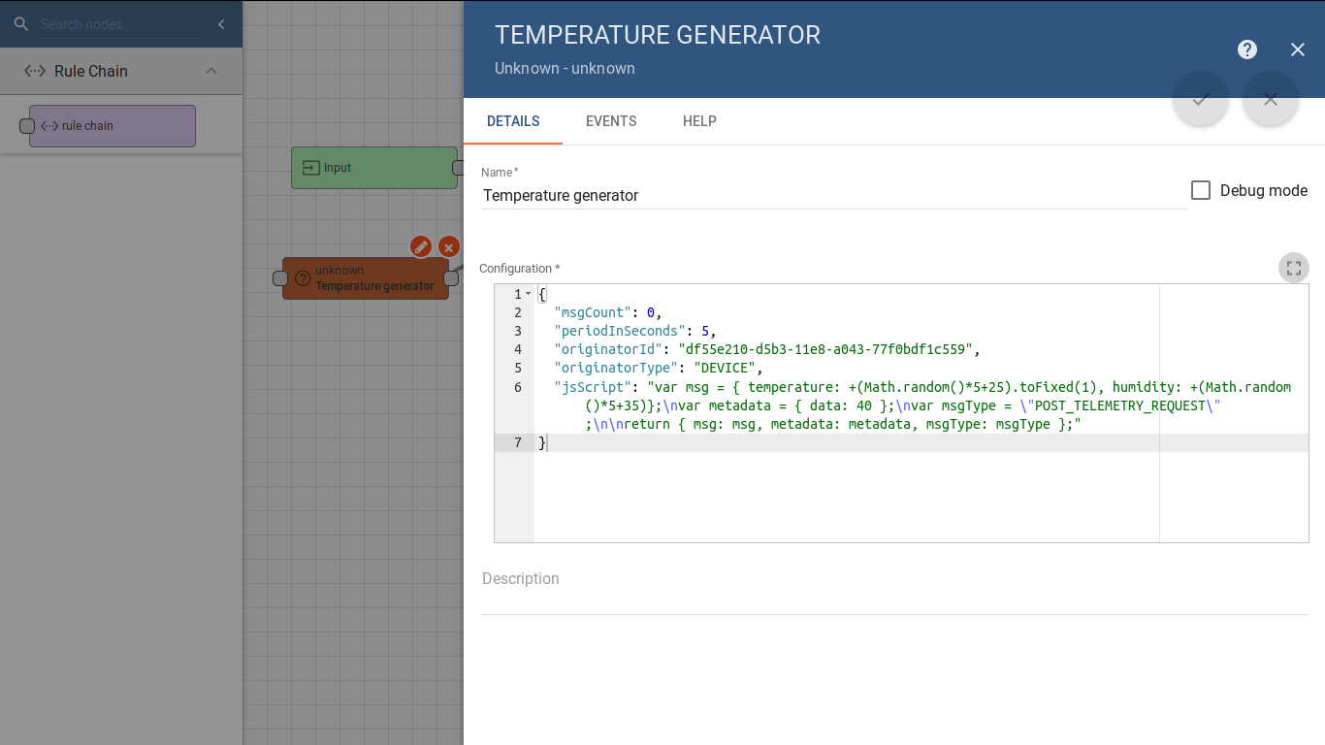
Figure 3.6 Temperature emulator

CHAPTER-4 DATA ANALYTICS

4.1 DATASET COLLECTION
We have collected the data from the NSS cell of our campus where the students have done a survey in the nearby villages and collected the huge data about their house holds. Using this data, we can perform many combinations of the data.
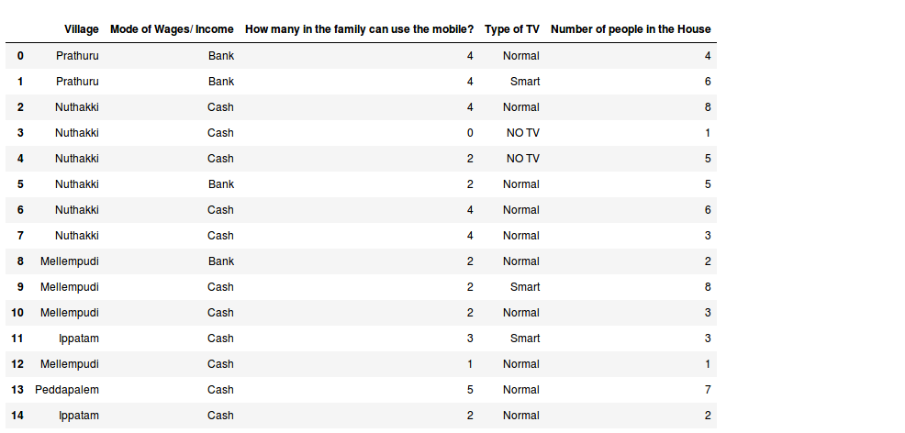
Figure 4.1 Sample Dataset

4.2 TOOLS AND PACKAGES USED
- Numpy
- Pandas
- matplotlib
- seaborn
- skikit-learn
- scipy

4.3 FEATURING AND SCALING OF DATA
Using data frames in Pandas, we can the information contained in the Dataset appropriately.
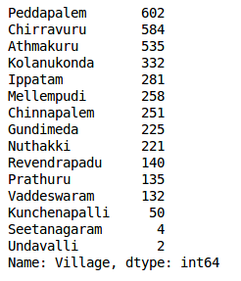
Figure 4.2 Data Information
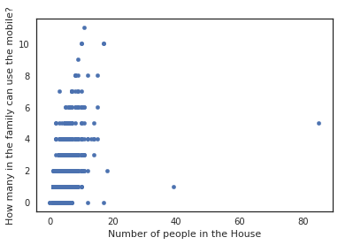
nss['Village'].value_counts()
nss.plot(kind='scatter',x='Number of people in the House', y='How many in the family can use the mobile?')
Figure 4.3 Scatter plot on NSS data
We can look at an individual feature in Seaborn through a boxplot. One way we can extend this plot is adding a layer of individual points on top of it through Seaborn's striplot use jitter=True so that all the points don't fall in single vertical lines above the species. Saving the resulting axes as ax each time causes the resulting plot to be shown on top of the previous axes.
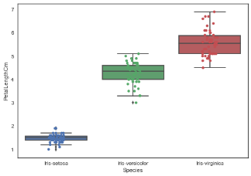
Figure 4.4 Box plot on Data

4.4 ANALYSING MODELS
SVM (Support Vector Machines):
Consider machine learning calculations as an arsenal stuffed with tomahawks, sword, sharp edges, bow, knife and so forth. You have different instruments, however you should figure out how to utilize them at the opportune time. As a similarity, consider 'Regression' a sword fit for cutting and dicing information productively, however unequipped for managing exceedingly complex information. In actuality, 'Support Vector Machines' resembles a sharp blade – it takes a shot at littler datasets, however on them, it very well may be substantially more grounded and amazing in building models. "Support Vector Machine" (SVM) is an administered machine learning calculation which can be utilized for both characterization or relapse difficulties. Be that as it may, it is for the most part utilized in arrangement issues. In this calculation, we plot every datum thing as a point in n-dimensional space (where n is number of highlights you have) with the estimation of each element being the estimation of a specific facilitate. Tuning parameters value for machine learning algorithms effectively improves the model performance. Let’s look at the list of parameters available with SVM.
There are three important parameters while modelling SVM namely “kernel”, “gamma” and “C”.

model = svm.SVC() # select the svm algorithm
# we train the algorithm with training data and training output
model.fit(train_X, train_y)
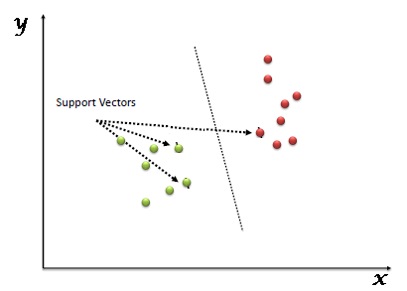
Figure 4.5 Understanding Support Vectors
# we pass the testing data to the stored algorithm to predict the outcome
prediction = model.predict(test_X)
print('The accuracy of the SVM is: ', metrics.accuracy_score(prediction, test_y)) # we check the accuracy of the algorithm
#we pass the predicted output by the model and the actual output
The accuracy of the SVM is: 0.172291296625

Logistic Regression:
Calculated Regression is a grouping calculation. It is utilized to foresee a twofold result (1/0, Yes/No, True/False) given an arrangement of free factors. To speak to parallel/clear cut result, we utilize sham factors. You can likewise consider strategic relapse as an exceptional instance of straight relapse when the result variable is downright, where we are utilizing log of chances as needy variable. In straightforward words, it predicts the likelihood of event of an occasion by fitting information to a logit work.
In logistic regression, we are only concerned about the probability of outcome dependent variable ( success or failure). As described above, g() is the link function. This function is established using two things: Probability of Success(p) and Probability of Failure(1-p). p should meet following criteria:
- It must always be positive (since p >= 0)
- It must always be less than equals to 1 (since p <= 1)
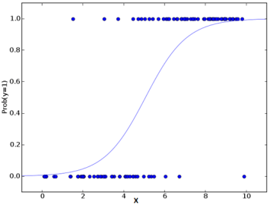
Figure 4.6 Demonstration of Logistic Regression Model
as shown in the figure above, Logistic Regression always lies between 0 and 1.

model = LogisticRegression()
model.fit(train_X, train_y)
prediction = model.predict(test_X)
print('The accuracy of Logistic Regression is: ', metrics.accuracy_score(prediction, test_y))

Decision Tree:
Decision tree is a sort of directed learning calculation (having a pre-characterized target variable) that is generally utilized in order issues. It works for both straight out and constant info and yield factors. In this strategy, we split the populace or test into at least two homogeneous sets (or sub-populaces) in light of most noteworthy splitter/differentiator in info factors.

model = DecisionTreeClassifier()
model.fit(train_X, train_y)
prediction = model.predict(test_X)
print('The accuracy of Decision Tree is: ', metrics.accuracy_score(prediction, test_y))
The accuracy of Decision Tree is: 0.177619893428
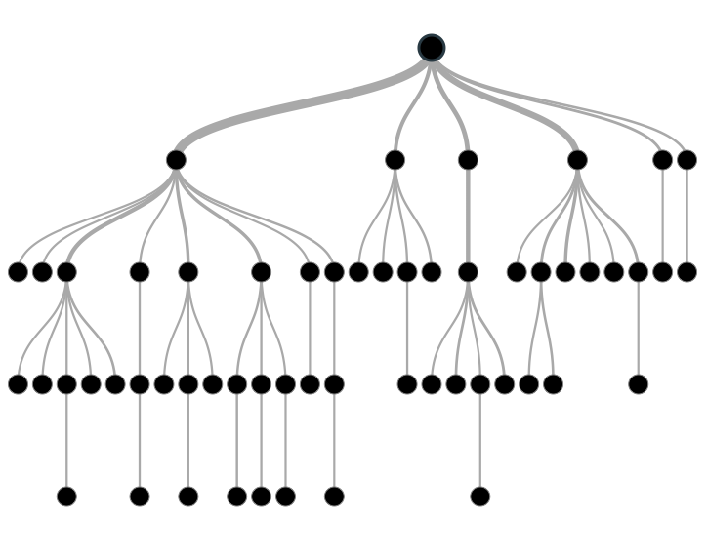
Figure 4.7 Decision Tree

K Neighbors Classifier:
KNN can be utilized for both grouping and relapse prescient issues. Notwithstanding, it is all the more generally utilized in characterization issues in the business. To assess any method we by and large take a gander at 3 critical viewpoints:
- Straightforwardness to translate yield
- Count time
- Prescient Power
We can implement a KNN model by following the below steps:
- Load the data
- Initialise the value of k
- For getting the predicted class, iterate from 1 to total number of training data points
  - Calculate the distance between test data and each row of training data. Here we will use Euclidean distance as our distance metric since it’s the most popular method. The other metrics
  - that can be used are Chebyshev, cosine, etc.
  - Sort the calculated distances in ascending order based on distance values
  - Get top k rows from the sorted array
  - Get the most frequent class of these rows
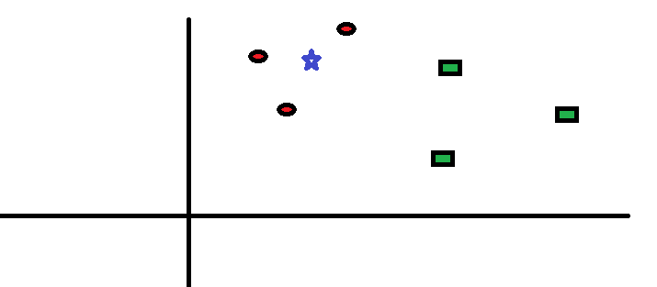
Figure 4.8 KNN model
model = KNeighborsClassifier(n_neighbors=3) # this examines 3 neighbors for putting the data into class
model.fit(train_X, train_y)
prediction = model.predict(test_X)
print('The accuracy of KNN is: ', metrics.accuracy_score(prediction, test_y))
The accuracy of KNN is: 0.137655417407

4.6 DATA VISUALIZATION
Matplotlib is an astounding perception library in Python for 2D plots of exhibits. Matplotlib is a multi-stage information perception library based on NumPy exhibits and intended to work with the more extensive SciPy stack. It was presented by John Hunter in the year 2002.
One of the best advantages of perception is that it permits us visual access to colossal measures of information in effectively edible visuals. Matplotlib comprises of a few plots like line, bar, dissipate, histogram and so on.
Matplotlib accompanies a wide assortment of plots. Plots comprehends patterns, designs, and to make relationships. They're ordinarily instruments for thinking about quantitative data. A portion of the example plots are secured here. One of the greatest benefits of visualization is that it allows us visual access to huge amounts of data in easily digestible visuals. Matplotlib consists of several plots like line, bar, scatter, histogram etc.
#sns.factorplot('How many in the family can use the mobile?', data=nss, hue='Village', kind='count' )

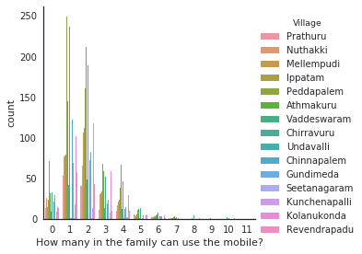
Figure 4.9 Analysis of NSS data
CHAPTER-5 PREDICTION OF WEATHER DATA
In this data colleted from IOT devices are used with IDLE tools

Anaconda
It is one amongst many Python distributions. Python distributions give the Python interpreter, beside a listing of Python packages and generally different connected tools, like editors. The Eunectes murinus Python distribution was best to put in on the University of Southampton student computers, however different distributions give similar practicality.

Instllation
• Download anconda3.7 from
“https://www.anaconda.com/download/#linux”
• run bash ~/Downloads/Anaconda3-5.3.0-Linux-x86_64.sh
anaconda-navigator to open anaconda
SPYDER
Spyder is a powerfull interactive development environent for the Python language with advanced editing, interactive testing, debuggind reflexion feactures.
SPYDER derives from "Scientific Python Development Environment" .
Feactures
• provision of the IPython (Qt) console as associate interactive prompt, which may show plots inline
• ability to execute snippets of code from the editor within the console
• continuous parsing of files in editor, and provision of visual warnings regarding potential errors
• bit-by-bit execution
• variable expolrer
Install on UNIX
$sudo apt-get install spyder3
Now update your cond with spyder3 and ensure to it update all latest packages in python.
Cassandra :
Apache prophetess could be a extremely scalable , superior distributed information designed to handle massive amounts of knowledge across several artefact servers, providing high accessibility with no single purpose of failure.
It is accustomed retrive knowledge from IOT devices and store it.

5.1 DATA RETREIVAL AND CLEANING
The data used in this series are collected from Weather Underground's free tier API net service.In this we have a tendency to use requests library to move with the API to tug in weather knowledge since 2014 once collected, {the knowledge|the info|the information} can got to be method and collective into a format that's appropriate for data.
He format of the request for the history API resource is as follows:
http://api.wunderground.com/api/API_KEY/history_YYYYMMDD/q/STATE/CITY.json
• API_KEY: The API_KEY that Weather Underground provides together with your account
• YYYYMMDD: A string representing the target date of your request
• STATE: the 2 letter state abbreviation within the us
• CITY: The name of the town related to the state you requested
from datetime import datetime, timedelta
datetime : a mixture of a date and a time
timedelta : A length expressing the distinction between 2 instances to unit of time resolution.
from collections import namedtuple
namesdtuple :Like dictionaries they contain keys that square measure hashed to a selected worth. however on contrary, it supports each access from key worth and iteration.
import pandas as pd
It's a package library written for the Python artificial language for knowledge manipulation and analysis
import requests
it's a Python HTTP library, discharged below the Apache2 License. The goal of the project is to create HTTP requests less complicated and a lot of human-friendly.
import matplotlib.pyplot as plt
Now i'll outline a handful of constants representing my API_KEY and therefore the BASE_URL of the API termination i'll be requesting. Note you may got to signup for associate account with Weather Underground and receive your own API_KEY. By the time this text is revealed i'll have deactivated this one.
BASE_URL could be a string with 2 place holders delineate by nappy brackets. the primary are crammed by the API_KEY and therefore the second are replaced by a string formatted date. each values are interpolated into the BASE_URL string victimization.
api_key = '7ad35052e3c73564'
base_url = "http://api.wunderground.com/api//history_/q/NE/Lincoln.json"
After aggregation a thousand days knowledge then set into pandas knowledge frame,with index of date
dataset = pands.DataFrame(records, columns=features).set_index('date')
Then, choose the feature variable based on some pirior knowledge of meteorology for three days
- mean temperature
- mean dewpoint
- mean pressure
- max humidity
- min humidity
- max dewpoint
- min dewpoint
- max pressure
- min pressure
precipitation
So next up is to work out some way to incorporate these new feastures as columns in our DataFrame. To do so I will make a smaller subset of the current DataFrame to make it easier to work with while developing an algorithm to create these features. I will make a test DataFrame consisting of just 10 records and features meantempm.
test = df[['meantempm', 'meandewptm']].head(55)
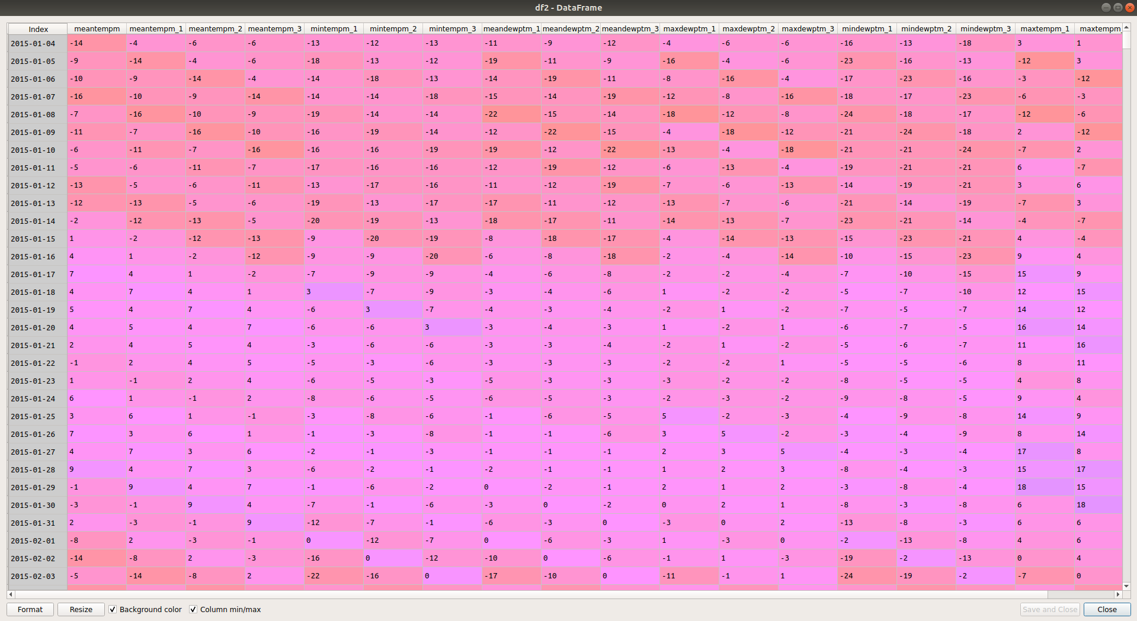
Figure 5.1 Sample Dataset

On thoese check knowledge and add needed options previous knowledge
For each day (row) and for a given feature (column) would really like to search out the worth for that feature N days previous. for every worth of N (1-3 in our case) i need to create a replacement column for that feature representing the ordinal previous data. Repeat this method for all the options attributes and add them to knowledgeset dataframe.
Data cleanup :
Data cleaning is a machine learning problem that needs data systems help! When dealing with real-world data, dirty data is the norm rather than the exception. We continuously need to predict correct values, impute missing ones, and find links between various data artefacts such as schemas and records.
Determine needless data, missing values, consistency of knowledge varieties, and outliers then creating some selections regarding a way to handle them if they arise.
Then chage the knowledge kind object -> float for each attribute.
Remove None value and replace with mean values in order to get better result and and more accuracy
Replace all NAN values to mean of its column or median inorder to get accuracy
to_remove = [feature
for feature in features
if feature not in ['meantempm', 'mintempm', 'maxtempm']]
# make a list of columns to keep
to_keep = [col for col in df.columns if col not in to_remove]
# select only the columns in to_keep and assign to df
df = df[to_keep]
df.columns
The first thing I want to do is drop any the columns of the DataFrame that I am not interested in to reduce the amount of data I am working with. The goal of the project is to predict the future temperature based off the past three days of weather measurements.

5.2 UNDERSTANDING THE DATA
The objective of the task is to anticipate the future temperature based off the previous three days of climate estimations
- mean temperature
- mean dewpoint
- mean pressure
- max humidity
- min humidity
- max dewpoint
- min dewpoint
- max pressure
- min pressure
- precipitation

To get pirior 3 days for every feacture
def derive_nth_day_feature(df, feature, N):
rows = df.shape[0]
nth_prior_measurements = [None]*N + [df[feature][i-N] for i in range(N, rows)]
col_name = "{}_{}".format(feature, N)
df[col_name] = nth_prior_measurements
for feature in features:
if feature != 'date':
for N in range(1, 4):
derive_nth_day_feature(df, feature, N)

And for good measure to take a look at the columns to make sure that they look as expected.
df.columns

Index(['meantempm', 'meandewptm', 'meanpressurem', 'maxhumidity',
'minhumidity', 'maxtempm', 'mintempm', 'maxdewptm', 'mindewptm',
'maxpressurem', 'minpressurem', 'precipm', 'meantempm_1', 'meantempm_2',
'meantempm_3', 'meandewptm_1', 'meandewptm_2', 'meandewptm_3',
'meanpressurem_1', 'meanpressurem_2', 'meanpressurem_3',
'maxhumidity_1', 'maxhumidity_2', 'maxhumidity_3', 'minhumidity_1',
'minhumidity_2', 'minhumidity_3', 'maxtempm_1', 'maxtempm_2',
'maxtempm_3', 'mintempm_1', 'mintempm_2', 'mintempm_3', 'maxdewptm_1',
'maxdewptm_2', 'maxdewptm_3', 'mindewptm_1', 'mindewptm_2',
'mindewptm_3', 'maxpressurem_1', 'maxpressurem_2', 'maxpressurem_3',
'minpressurem_1', 'minpressurem_2', 'minpressurem_3', 'precipm_1',
'precipm_2', 'precipm_3'],
dtype='object')

Then visualize each attribute from test data
df.maxhumidity_1.hist()
plt.title('Distribution of maxhumidity_1')
plt.xlabel('maxhumidity_1')
plt.show()
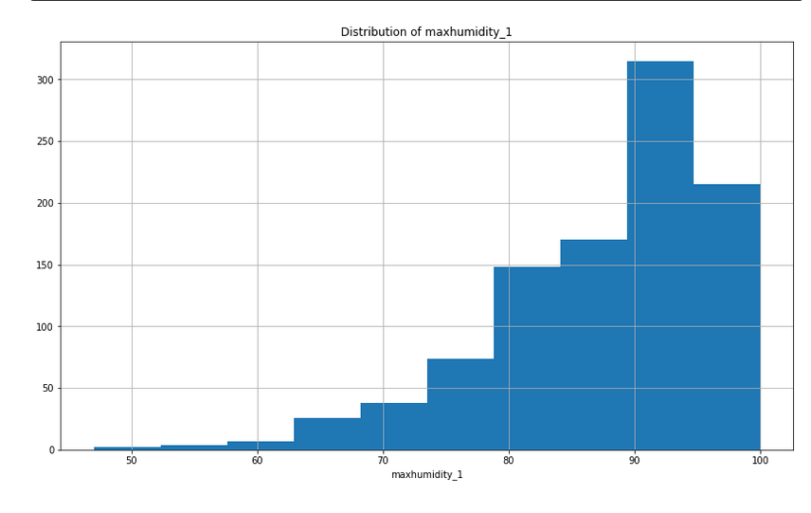
Figure 5.2 Vizualization of each attribute from test data

Looking at the bar chart of the values for maxhumidity the information exhibits quite little bit of negative skew. i will be able to need to stay this in mind once choosing prediction models and evaluating the strength of impact of liquid ecstasy humidities. several of the underlying applied mathematics ways assume that the information is often distributed. For currently i believe i will be able to leave them alone however it'll be sensible to stay this in mind and have an explicit quantity of skepticism of it.
Choose higher feature to predict and dont choose that take a lot of variance .
Next I will look at the minimum pressure feature distribution.
df.minpressurem_1.hist()
plt.title('Distribution of minpressurem_1')
plt.xlabel('minpressurem_1')
plt.show()
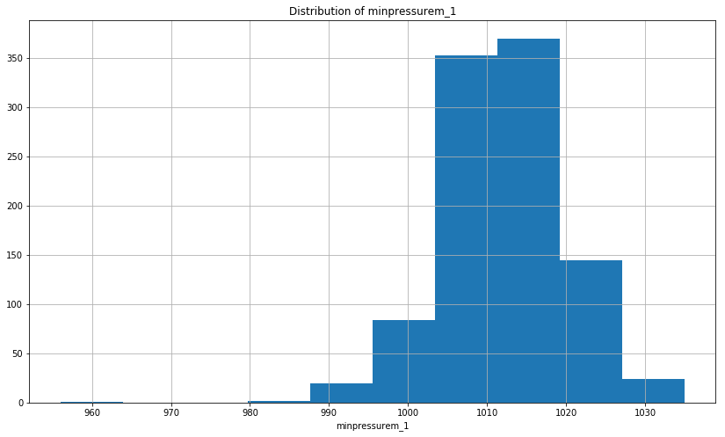 Figure 5.3 Histogram Plot of the data
This plot exhibits another fascinating feature. From this plot, information|the info|the information} is multidimoal that leads me to believe that there square measure 2 terribly totally different sets of environmental circumstances apparent during this data. i'm hesitant to get rid of these values since i do know that the temperature swings during this space of the country are often quite extreme particularly between seasons of the year. We disquieted that removing these low values might need some instructive utility however, once more i'll be skeptical regarding it at identical time.
After improvement and feature Scalling data the select the most effective algorithm that matches your model.
5.3 DIVIDING DATA INTO TRAINING AND TESTING DATASETS
Isolating information into training and testing sets is a critical piece of assessing information mining models. Normally, when you separate an informational collection into a training set and testing set, the majority of the information is utilized for training, and a littler part of the information is utilized for testing.
from sklearn.model_selection import train_test_split
By using train_test_split function in model_selection module at SkLearn Package. At presrent we have 1000 dates of data from that the tran and test data ratio mudt be in the ratio of 7:3 in order to get better result and aviod model from over fitting
X_train, X_test, y_train, y_test = train_test_split(X, y, test_size=0.2, random_state=12) By this the train data has 797 and test data has 200 data entries.
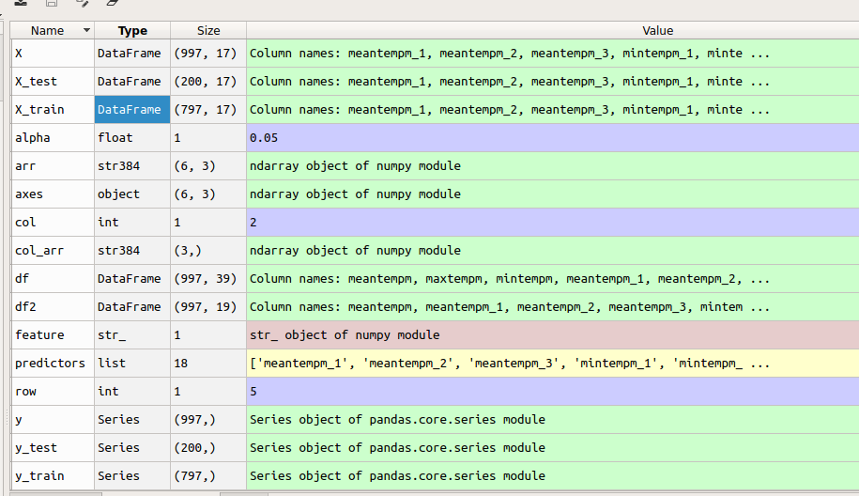
Figure 5.4 Training and testing datasets

5.4 APPLYING REGRESSION MODELS
A s our predicted value ought to vary for each time it falls into Regressor kind.so,check all the regerssor modles that fit our model .In regression toward the mean using normal statistical method suits more.
So, we should try all regression models to predict weather data

Support Vector Algorithm (SVM):
Support Vector Machine can also be used as a regression method, maintaining all the main features that characterize the algorithm (maximal margin). The Support Vector Regression (SVR) uses the same principles as the SVM for classification, with only a few minor differences. First of all, because output is a real number it becomes very difficult to predict the information at hand, which has infinite possibilities.
In the case of regression, a margin of tolerance (epsilon) is set in approximation to the SVM which would have already requested from the problem. But besides this fact, there is also a more complicated reason, the algorithm is more complicated therefore to be taken in consideration. However, the main idea is always the same:
to minimize error, individualizing the hyperplane which maximizes the margin, keeping in mind that part of the error is tolerated.

from sklearn.preprocessing import StandardScaler

sc_X = StandardScaler()
sc_y = StandardScaler()
X = sc_X.fit_transform(X)
y = sc_y.fit_transform(y)

Pre-processing :
The sklearn.preprocessing package provides several common utility functions and transformer classes to change raw feature vectors into a representation that is more suitable for the downstream estimators.
StandardScaler :
Standardize features by removing the mean and scaling to unit variance.
By this the feature data and dependent data will be set common fitting and ready to fit into svr model.

from sklearn.svm import SVR
regressor = SVR(kernel = 'rbf')
regressor.fit(X, y)
prediction = regressor.predict(X)
In sklearn SVR model is imported and fit with our data and predict test data
but,regressor socre is low and changes to next model

Ordinary Least Squares Model
Linear regression aims to apply a set of assumptions primary regarding linear relationships and numerical techniques to predict an outcome (Y, aka the dependent variable) based off of one or more predictors (X's independent variables) with the end goal of establishing a model (mathematical formula) to predict outcomes given only the predictor values with some amount of uncertainty.
Correlation values from 0 to -1 are said to be inversely, or negatively, correlated in that when the values of one series increase the corresponding values in the opposite series decrease but, as changes in magnitude between the series become equal (with opposite direction) the correlation value will approach -1. Pearson correlation values that closely straddle either side of zero are suggestive to have a weak linear relationship, becoming weaker as the value approaches zero.
Opinions vary among statisticians and stats books on clear-cut boundaries for the levels of strength of a correlation coefficient. However, I have found that a generally accepted set of classifications for the strengths of correlation are as follows:
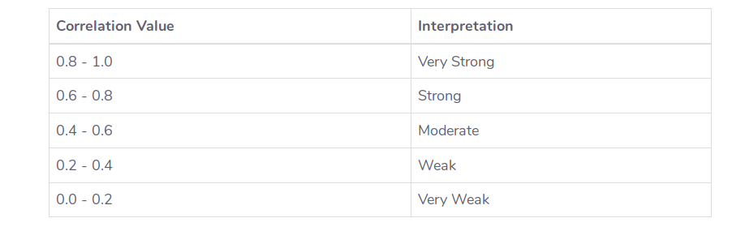
Figure 5.5 Ordinary Least Squares Model

To assess the correlation in this data I will call the corr() method of the Pandas DataFrame object. Chained to this corr() method call I can then select the column of interest ("meantempm") and again chain another method call sort_values() on the resulting Pandas Series object. This will output the correlation values from most negatively correlated to the most positively correlated.
By folling command the sorted corelation values will display
df.corr()[['meantempm']].sort_values('meantempm')
Visualizing the Relationships
Significantly and more familiar with seeing visuals to evaluate and verify patterns, we will chart every one of these chosen indicators to demonstrate to myself that there is in a direct relationship. To do this we will use matplotlib's pyplot module.
For this plot we might want to have the needy variable "meantempm" be the steady y-axis along the majority of the 18 indicator factors plots. One approach to achieve this is to make a lattice of plots. Pandas comes with a helpful plotting capacity called the scatter_plot(), yet I for the most part just utilize it when there are just up to around 5 factors since it transforms the plot into a N x N lattice (18 x 18 for our situation), which winds up hard to see points of interest in the information. Instead I will create a grid structure with six rows of three columns in order to avoid sacrificing clarity in the graphs.

import matplotlib
import matplotlib.pyplot as plt
plt.rcParams['figure.figsize'] = [16, 22]
fig, axes = plt.subplots(nrows=6, ncols=3, sharey=True)
arr = np.array(predictors).reshape(6, 3)
for row, col_arr in enumerate(arr):
for col, feature in enumerate(col_arr):
axes[row, col].scatter(df2[feature], df2['meantempm'])
if col == 0:
axes[row, col].set(xlabel=feature, ylabel='meantempm')
else:
axes[row, col].set(xlabel=feature)
plt.show()
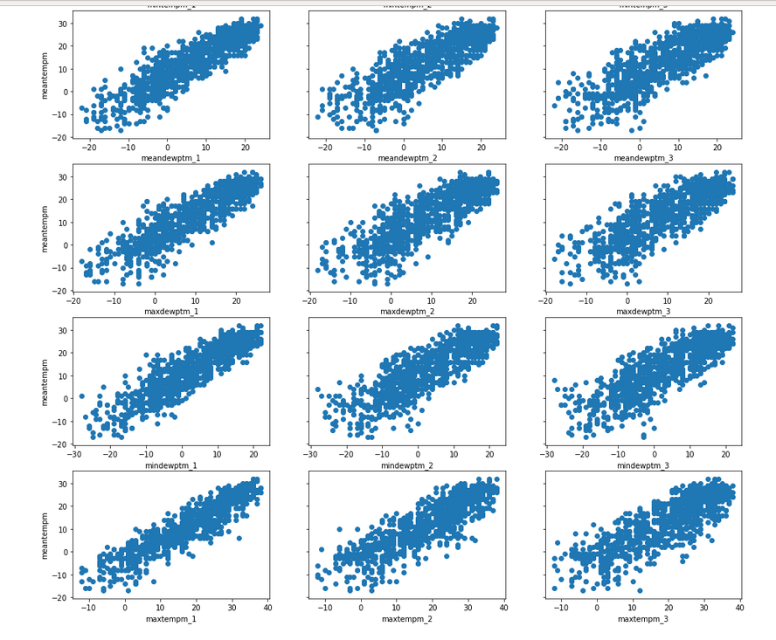
Figure 5.6 Visualization of relationships
import statsmodels.api as sm
Statsmodels is a libary gives classes and capacities to the estimation of various factual models, and for directing measurable tests, and measurable information investigation
model = sm.OLS(y, X).fit()
print("The Explained Variance: %.2f" % regressor.score(X_test, y_test))
print("The Mean Absolute Error: %.2f degrees celsius" % mean_absolute_error(y_test, prediction))
print("The Median Absolute Error: %.2f degrees celsius" % median_absolute_error(y_test, prediction))
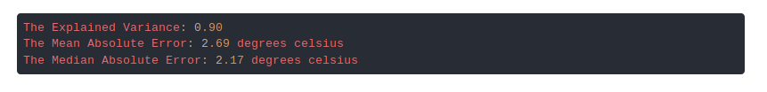
Figure 5.7 Mean Absolute Error
To gain an interpretative understanding of the models validity I used the regressor model's score() function to determine that the model is able to explain about 90% of the variance observed in the outcome variable, mean temperature. Additionally, I used the mean_absolute_error() and median_absolute_error() of the sklearn.metrics module to determine that on average the predicted value is about 3 degrees Celsius off and half of the time it is off by about 2 degrees Celsius.

CHAPTER-6 CONCLUSION
In this project a weather station has been developed to measure the temperature and relative humidity inside or outside the room on the present time and then share this information on a server through internet where it can be processed and monitoring for various purpose. IOT weather reporting system has application to farmers as well. The weather forecasting plays very important role in the field of agriculture. IOT weather monitoring project proves really helpful for monitoring weather at places like volcano, rain forests. It is quite difficult for a human being to stay for longer time at such places. Or even areas which are exposed to radioactive leakage. IOT weather monitoring system project using NodeMCU and Thingsboard is fully automated. It does not require any human attention. You can get a prior alert of the weather conditions. Suppose you are planning to visit a place and you want to know the weather parameters over that place, then you can just visit a website IOT portal. Future enhancements to this IOT project. We implemented the Machine Learning models to predict the weather conditions of the future with the current and past values. As of now, we have collected the Dataset from external sources to predict the temperatue and humidity.

CHAPTER-7 FUTURE SCOPE
This will conclude that the real time data successfully helpful because there is difficulty in prediction of future weather. The future of this model is very wide. IoT is just opening its arms, same system can be applicable to various applications like data monitoring, sending and controlling of data at remote locations. The fields of IOT and Machine Learning have been gaining rapid attention to both business analysts and researchers due its ease of use and rapid development platforms. Furthermore, we can implement this project to work by using the live data from the harware device located in various weather stations. We can also use the relative difference between the temperatures of different regions.

CHAPTER-8 REFERENCES
https://www.eclipse.org/community/eclipse_newsletter/2014/february/article2.php
https://thingsboard.io/docs/user-guide/visualization/
https://www.analyticsvidhya.com/blog/2018/03/introduction-k-neighbours-algorithm-clustering/
https://demo.thingsboard.io/home
http://nodemcu.com/index_en.html
https://thingsboard.io/docs/samples/nodemcu/temperature/
https://iotbytes.wordpress.com/store-mqtt-data-from-sensors-into-sql-database/
https://www.researchgate.net/profile/Steve_Gallant/publication/5569039_Perceptron-based_learning_algorithms/links/0f3175344302564821000000.pdf
https://www.mouser.in/Sensors/Temperature-Sensors/Board-Mount-Temperature-Sensors/_/N-7gz7q?P=1yzognn
https://www.survivingwithandroid.com/2016/10/mqtt-protocol-tutorial.html
https://www.allaboutcircuits.com/projects/introduction-to-the-mqtt-protocol-on-nodemcu/
https://www.electronicshub.org/wp-content/uploads/2017/06/DHT11-Humidity-Sensor-on-Arduino-Circuit-Diagram.jpg
https://nodemcu.readthedocs.io/en/master/en/modules/wifi/
https://www.survivingwithandroid.com/2016/10/mqtt-protocol-tutorial.html
https://stackabuse.com/using-machine-learning-to-predict-the-weather-part-1/
https://stackabuse.com/using-machine-learning-to-predict-the-weather-part-2/
https://stackabuse.com/using-machine-learning-to-predict-the-weather-part-3/

